**Report for Inspection and Survey for**

This report is part of our commitment to identifying what we can do to improve the surroundings, structure, and communal areas of your home. We have noted your comments and will liaise with various teams to see what can be undertaken as per your recommendations.

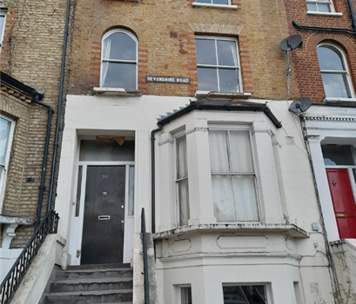

Windows

Comments

Driveway

Comments

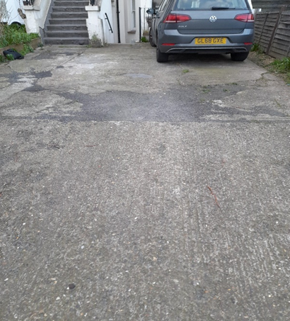

Front of the Building

Comments

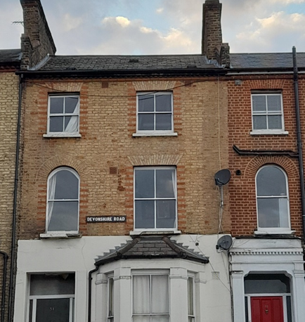

Rear of the Building

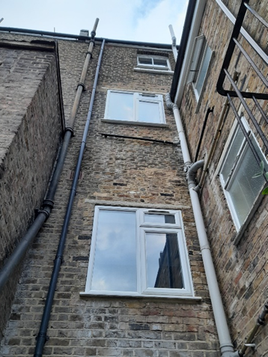Comments

Garden Area and Steps

Comments

