Hexagon’s Customer Services Committee
Date:
Agenda Item
Report Title | Hearing the customer voice
Purpose | Discussion ☒ | Decision ☐ |  | Information ☐ | Approval ☐
Author(s): | Andy Vincent, Operations Director
Contact info | avincent@hexagon.org.uk |  |  | T: 020 8768 7914
Appendix(ces)
- Recommendations

  - It is recommended that committee members note the customer contact and feedback received by Hexagon between DATE and DATE.

  - Section BLANK of this report the proposed actions to address concerns raised.

- Purpose

  - The purpose of this paper is to: -

- Collate the customer contact themes received by Hexagon between November 2023 and March 2024 and look at trend data.
- Capture customer feedback received between November 2023 and March 2024, comparing perception and transactional survey results.
- Identify the themes of the concerns raised and details actions to address them.

- Background

  - Hexagon captures resident contacts to the organisation via its Customer Relationship Management system and via its complaints procedure.

  - Hexagon also surveys residents on a quarterly basis, in line with the requirements of the Tenant Satisfaction Measures, and transactionally after a variety of interactions, including the completion of a repair works order, the completion of a call to the contact centre, and the creation of a new tenancy agreement (see Appendix 1 for full list)
- Main content

  - Hexagon has begun to more systematically categorise the contact we receive from residents, as we implement our new CRM system. While we were recording customer contacts previously, this categorisation only began in November of 2023.
  - Customer contacts are now categorised in a detailed hierarchy, which is shown below. The first chart categorises each contact by which team it relates to. The second categorises each contact according to subject.
  - Naturally, residents contact us about many subjects, so the second chart is very busy. However, it can be filtered according to team. The third chart is a version of the first chart, filtered to only show those contacts relating to the Responsive Repairs team
  - We are at the beginning of our journey in collecting and analysing this data to better understand the needs of our residents, but can already glean some insights are apparent, including:
    - We had over 400 contacts in February from residents regarding ongoing repair works. This represents almost 20% of all customer contact received, and suggests that residents are not contacting Gilmartins, or if they are, are not receiving the resolution they need
    - Since the categorisation has begun, ASB and Parking were two of the most common reasons for residents to contact the Neighbourhoods team (440, and 245 contacts, respectively)
    - Since categorisation has begun, we have received very few queries about service charges – just 28 out of over 1,900 contacts for the revenue team, and over 12,000 across the organisation as a whole.
  - Note that these are illustrative examples of the capabilities we are building to better understand our residents, not definitive findings on which to base changes in our services.
Chart 1 – CRM Communications by Team
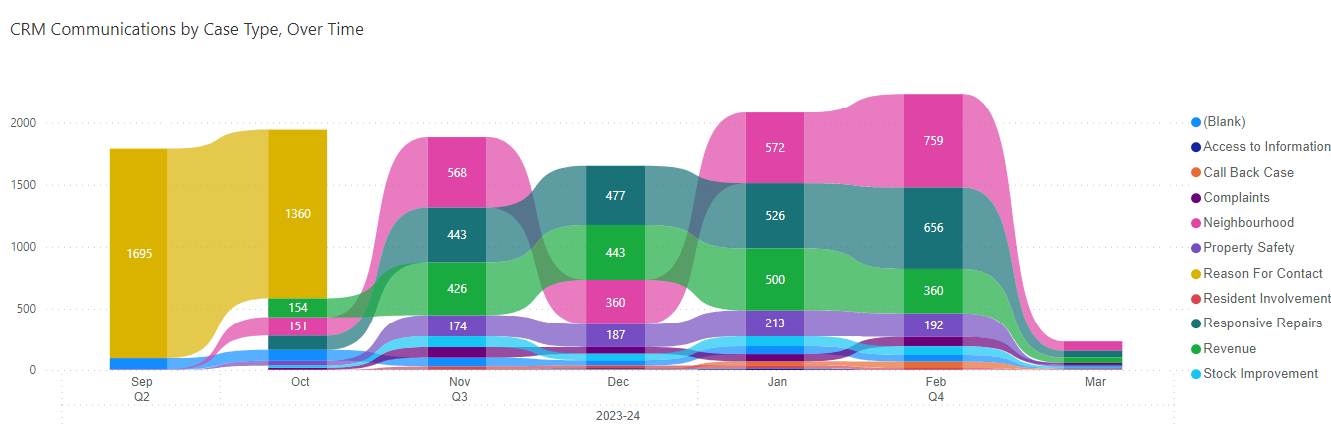
Chart 2 – CRM Communications by Subject
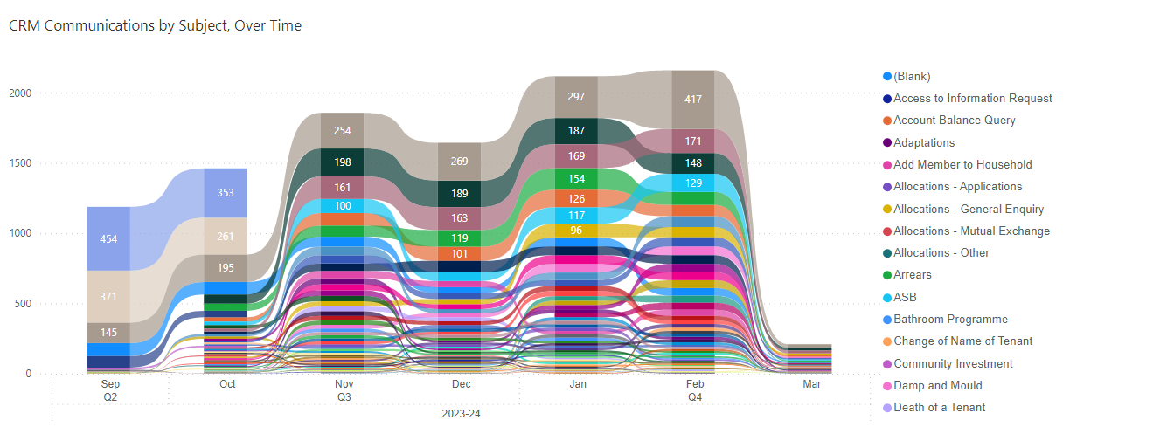
Chart 3 – CRM Communications by Subject – Repairs Only
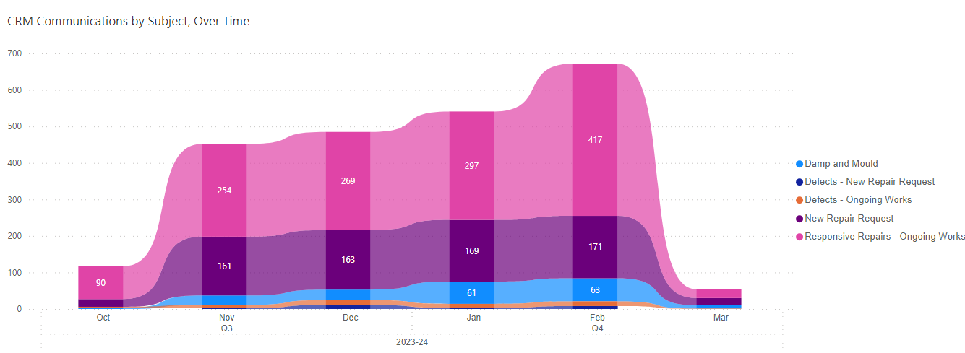
  - Hexagon has also begun to categorise the complaints it receives, according to the team the complaint is attributable to. As the chart below shows
Chart 4 – Complaints Received by Team
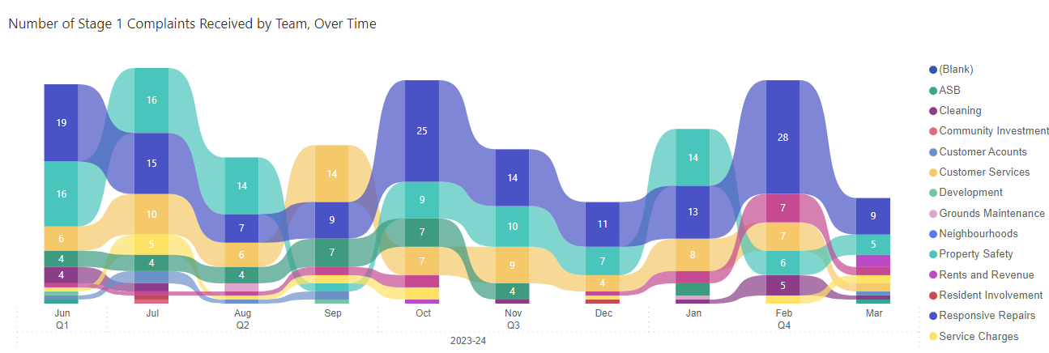

  - As noted, Hexagon also collects a wide variety of survey data. The results of those surveys as of the end of January are shown below. Note that the lettings satisfaction survey has only recently launched, so we have not yet collected enough responses to report findings from it. Transactional surveys for ASB handling and maintenance of communal areas are currently in development, and additional surveys on planned works and fire safety are also planned.
 | Q1 23/24 | Q2 23/24 | Q3 23/24 | Q4 23/24 QTD | 23/24 YTD
Repairs satisfaction survey (transactional)
% satisfied with last repair | 75.9% | 67.6% | 57.5% | 58.5% | 65.7%
% satisfied with quality of work | 74.1% | 67.0% | 57.5% | 60.2% | 65.3%
% satisfied with speed of work | 73.6% | 68.9% | 56.7% | 58.5% | 65.1%
% satisfied with tidiness of work | 80.5% | 73.2% | 66.0% | 67.8% | 72.5%
% satisfied Hexagon is easy to deal with | 71.3% | 65.9% | 58.9% | 59.6% | 64.6%
Contact centre survey (transactional)
Customer satisfaction with contact centre | 68% | 66% | 65% | 63% | 66%
% satisfied with customer care received | 70% | 68% | 68% | 65% | 68%
% satisfied with adviser | 69% | 66% | 68% | 67% | 68%
% satisfied with adviser attitude | 75% | 74% | 74% | 75% | 74%
Quarterly TSM Survey
% Residents satisfied with overall service received | 54.0% | 56.0% | 50.0% | - | 53.0%
% satisfied that Hexagon listens to the tenant views and acts upon them | 53.0% | 43.0% | 43.0% | - | 46.0%
% satisfied that Hexagon keeps tenants informed about things that matter to them | 65.0% | 63.0% | 66.0% | - | 65.0%
% satisfied that Hexagon treats tenants fairly and with respect | 61.0% | 67.0% | 63.0% | - | 63.0%
% satisfied that Hexagon is easy to deal with | 57.0% | 58.0% | 59.1% | - | 58.0%
% satisfied that Hexagon provides a home that is safe | 66.0% | 67.0% | 63.0% | - | 65.0%
% satisfied that Hexagon provides a home that is well-maintained | 53.0% | 57.0% | 49.0% | - | 53.0%
% satisfied that Hexagon keeps communal areas clean and well-maintained | 46.0% | 49.0% | 57.0% | - | 51.0%
% satisfied with the overall repairs service from Hexagon in the last 12 months | 50.0% | 56.0% | 55.0% | - | 54.0%
% satisfied with time taken to complete most recent repair | 48.0% | 56.0% | 62.0% | - | 55.0%
% satisfied that Hexagon makes a positive contribution to your neighbourhood | 49.0% | 52.0% | 55.0% | - | 52.0%
% satisfied with Hexagon's approach to handling ASB | 46.0% | 59.0% | 52.0% | - | 53.0%
% satisfied with Hexagon's approach to complaints handling | 27.0% | 27.0% | 14.0% | - | 23.0%

4.5 The table below highlights the themes of concerns raised within the transactional surveys.

Survey Type | Theme(s) of concerns raised
Anti-social behaviour
Repairs
Lettings

4.6 Actions to address the concerns raised: -

4.7 The follow resident engagement event(s) have been held between DATE and DATE.

4.8 Issues to address following the events are as follows: -

- Next steps
  - The following actions are contained within existing corporate (annual delivery plan) or team level plans.
  - The following additional actions will be
- Corporate Governance

Links to Corporate Plan | Hearing and responding to resident feedback aligned to the following Corporate Plan objectives.  - Good landlord services that meet customer needs  - Residents are supported and making a positive difference
Impact on residents/staff | Focusing on residents’ priorities and concerns should have a positive impact on customer satisfaction and enable residents to see demonstrable evidence that  Hexagon responds to their concerns.
Risks/strategic impact | SR1, SR2 and SR5 relate to the above corporate plan objectives.
Governance/Regulatory implications | Hearing the customer voice aligns to the Transparency, Influence and Accountability regulatory consumer standard.
Financial implications | This report has no financial implications.
Equality and Diversity | Future work will be undertaken to explore the profile of residents contacting Hexagon and participating in survey activity.
Value for money | This report does not consider value for money

Appendix 1 – List of Hexagon Resident Satisfaction measures
Survey | Survey Type | Measures
Quarterly TSM Survey | Perception | % satisfied with the overall service provided by Hexagon
 |  | % satisfied that Hexagon provides a home that is well maintained
 |  | % satisfied that Hexagon provides a home that is safe
 |  | % satisfied that Hexagon keeps communal areas clean and well maintained
 |  | % satisfied with the overall repairs service from Hexagon over the last 12 months
 |  | % satisfied with the time taken to complete most recent repair
 |  | % satisfied that Hexagon is easy to deal with
 |  | % satisfied that Hexagon listens to your views and acts upon them
 |  | % satisfied that Hexagon keeps you informed about things that matter to you
 |  | % Agree that “Hexagon treats me fairly and with respect”
 |  | % satisfied that Hexagon makes a positive contribution to your neighbourhood
 |  | % satisfied with Hexagon's approach to handling anti-social behaviour
 |  | % satisfied with Hexagon's approach to complaints handling?
Repairs satisfaction survey | Transactional  (sent after a works order is completed) | % satisfied with the overall repair service provided by Gilmartins, on behalf of Hexagon, on this occasion
 |  | % satisfied with the speed of completion of the work
 |  | % satisfied with the overall quality of the work
 |  | % satisfied with keeping dirt and mess to a minimum
 |  | % satisfied that Hexagon was easy to deal with
 |  | % confirm that the contractor arrived during the agreed timeslot
Contact centre satisfaction survey | Transactional  (sent after a call to the contact centre is completed) | % satisfied with the adviser who helped you
 |  | % satisfied with the attitude of our customer adviser
 |  | % satisfied with the customer care you received
 |  | % satisfied that you received the result you needed
 |  | % overall satisfied with the contact centre
Lettings satisfaction survey | Transactional  (sent after a new rental agreement is created) | % agree that “the information received throughout the viewing and sign-up process was clear and easy to understand”
 |  | % agree that “any questions or queries I had regarding the property and sign-up process were answered quickly and efficiently”
 |  | % agree that “I received all of the necessary information about the property when I moved in”
 |  | % agree that “I found Hexagon easy to deal with throughout the process”
 |  | % agree that “overall, I was happy with the overall lettings process”

