Annual Review Resident Voice and Engagement
Date: | 2nd May 2024
Report Title | Annual review
Purpose | Update DG on the service during 2023/24
Author(s): | Nicky Hazelwood

1 | Summary
This report gives an overview of the activities of the Resident Voice and Engagement Team for the period April 2023 to end March 2024 and identifies the priorities for 24/25.

Due to staff absence, no Annual Review was produced in 2023.

The Resident Engagement Strategy was initially due to be approved in Summer 2023, however, the decision was taken to take a step back, review and refine our resident engagement activities, ensure alignment with the new consumer standards and ensure a strengthened feedback loop is in place.

The draft strategy was presented to Customer Services Committee in March 2024, Directors Group in April, and subject to final amendments is due to be presented to the Board in May 2024.

Therefore, the priorities for 2023/24 were based on existing commitments, the Annual Delivery Plan, and the development of the new Resident Engagement Strategy.

The priorities for 2024/25 are aligned to the Annual Delivery Plan and the draft strategy.
2 | Recommendations
That DG approves the following priorities for 2024/25 which are in line with the Corporate plan, Annual Delivery Plan and the draft Resident Engagement Strategy 2024-27:
- Review engagement options to ensure they are inclusive, reflect our customers’ preferred methods of engagement and build on best practice
- Organise Big Conversation, where each Hexagon colleague contributes to an extensive resident consultation which sets out to achieve a number of outcomes will include: Resident engagement priorities identified; Consultation on service delivery including digital self service; Access to services, identification of vulnerabilities, reasonable adjustment requests and adjustments made
- Increase resident awareness of routes for how they can hold Hexagon to account on standards for service delivery, strategy, performance and decision making
- 'Hearing the Customer Voice' - collaborative work with CSC Manager and others to develop a framework for hearing more customer voices, identifying areas for service development and feeding back to residents
- Embed new Chairs’ networking group and Resident Engagement 360
- We will seek to adopt a ‘Together with Tenants’ approach, and work collaboratively with residents to develop a Tenants Charter and in doing so, provide affirmation of Hexagon's commitment to resident engagement.
- Strengthen and regularize resident scrutiny of service areas, with a feedback loop on progression of recommended actions
- Seek TPAS accreditation for Resident Engagement. Develop an action plan to ensure accreditation is achieved in 2025/26
- Develop a resident engagement hub, the digital home for improvement plans, performance data, policies and procedures, resident engagement, feedback and response to the feedback.
- Review and refine the Estate Champions processes. Improve residents' ability to influence services delivered within their communities by increasing the number of Estate Champions to at least 15 actively working with Neighbourhoods Team to monitor the communities in which they live.
- Collaborate with the Repairs Group and other residents to review damp and mould related communications, aimed at helping them to avoid damp and mould in their homes
- Consult with residents of High Risk buildings and deliver an engagement plan reflecting preferred methods of engagement.
- Development of Home Ownership Network

3 | Resident Voice & Engagement Review
Resident engagement has gone through and is going through a period of change. Hexagon has a long history of resident engagement, a wide range of activities and structures which have evolved over the years. However, it was unclear what impact the activities were having.

Feedback on the draft strategy was that it was too ambitious and would prove difficult to deliver. We therefore took time to pause the development of the new Resident Engagement Strategy, review and reset our activities.

The team functioned at reduced capacity for much of the year due to staff absence, the Community Investment Manager covered limited activities during this time. Moving forward, the Community Investment Manager will split their time between Resident Engagement and Community Investment Teams.

4 | Performance against Priorities
4.1 | Estate Grading  Estate Grading is a valuable scrutiny project and a good example of partnership work with the active involvement of Services in the process from the outset through to delivery of actions.  The process involves a small team of resident volunteers visiting a list of identified estates and completing a grading assessment. The assessment covers areas such as grounds maintenance and cleaning, communal areas, health and safety, notice boards and signage. Each individual estate is scored and awarded a grade from bronze to gold. An action plan is formulated and agreed, with four weeks an agreed timescale for completion.  Outcome  The spot check assessments are an independent scrutiny function which help ensure we live up to our commitments under our Estate Services Standards.  The partnership approach with service managers can help ensure completion of actions in a timely manner, however even though an action plan and timescales are agreed at the outset, a degree of chasing by the team is often required to ensure completion of actions.  The assessments completed in June 2023 still had 12% of actions not completed or without update, this reduced to 1.5% by November 2023. The delays were largely driven by capacity issues.
4.2 | Estate Champions  Estate Champions are volunteer residents who inspect estates to monitor upkeep and standards. For example they will offer feedback on issues such as grounds maintenance, mildew on walls, waste storage and collection, salt supply on frozen driveways, vandalism of fire alarms and water supply pipes, communal lighting, communal cleaning, entry systems, lifts and car parks.  Estate Champions can be the ‘eyes’ on the estate‘, helping ensure swift responses to issues.  Outcomes  The number of Estate Champions has dropped over the last couple of years.  The reporting mechanisms and impact of Estate Champions is unclear. We are currently reviewing the Estate Champions function to ensure a clear connection between resident volunteers actions, estates upkeep and resident satisfaction.
4.3 | The Resident Scrutiny Inspectors are a small group of residents who complete an independent review of a service each year. The most recent inspection was completed in October 2022 with an agreed action plan 2022, it was a review of Estate Inspection Service to assess whether the service was working effectively from a resident’s perspective. It also looked at whether Hexagon are delivering the service in accordance with service standards and service agreements.  Outcomes  The Inspection Team made 10 recommendations which focus on opportunities to improve quality assurance; enhance communication; and support clarity and consistency in the implementation of Service Standards & Service Agreement.  It was also agreed that a review would be undertaken after 6 months to review the impact to the recommendations.  At the time of writing XXXXXXXXXXXXXXXXX
4.4 | Procurement of New Estate Services Contract  A small group of resident volunteers were involved in the procurement of the new Estate Services contract. Residents involved in this process had either attended a focus group at service design phase and/or had been involved in the Inspection of Estate Inspections.  Residents remained engaged in the mobilisation of the new contract, the group evolved into a Sounding Board, and an action plan agreed.  Outcome  Due to reduced capacity within the Neighbourhoods Team, progress against the action plan has been delayed and communications stunted.
4.5 | Performance Review Group  Ensure resident’s priorities are central in the scrutiny of Hexagon’s service performance. The group makes recommendations which feed into the Customer Services Committee or the Board where applicable.  Outcomes  The group met 4 times, and held an additional meeting with CSC regarding complaints.  Minutes with actions and recommendations from meetings alongside quick read notes and reported to CSC. There is a tracker designed to capture actions and track through to completion, though it is difficult to ascertain how many of these have led to successful outcomes.  The Chair of PRG and CSC attend respective meetings to help with the feed of information and actions from both groups.  The participant survey completed at the end of each meeting reported 100% yes for each of the questions: Did you feel able to speak if you wanted-to; felt listened to; and felt the group made a difference
4.6 | Repairs Group  Scrutinise, challenge and learn lessons in the responsive repairs service; making suggestions to help improve performance, service and value for money on behalf of residents. Recommendations are reported to the Service Manager and Head of Service; with resulting actions responded to and the Repairs Group empowered to monitor outcomes. Repairs Group has a relationship to the Performance Review Group (PRG) which is expressed by: sending regular reports on its work to the PRG having PRG members on its membership being empowered to make recommendations to the PRG.  Outcomes  The group met 6 times, and recommended actions against 91 issues. The chart below shows progress made.  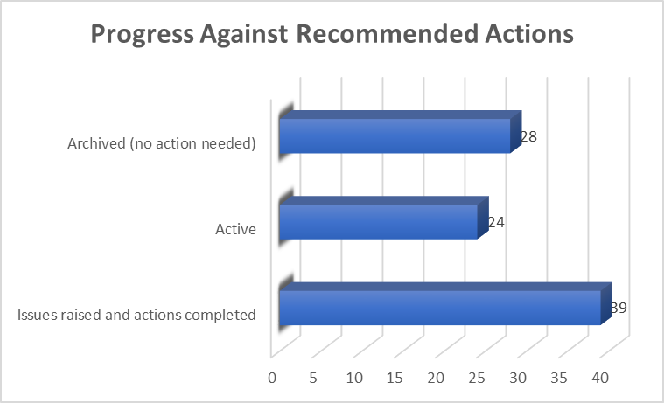  At the end of each meeting, participants are asked to complete a survey. The chart below shows post meeting feedback for 2023/24.  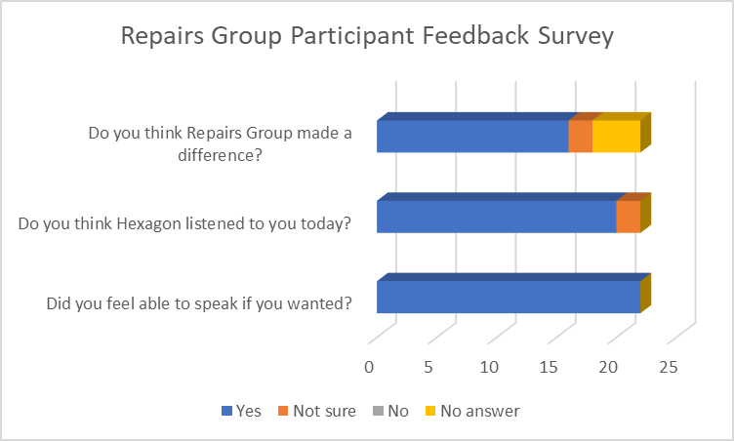
4.7 | Repairs Open Meetings  In July 2023, two Repairs Open Meetings were held. The meetings were held to help us understand the quality if the service, what is working, what is not working so well. The meetings were well attended by residents, had several Hexagon Managers and Gilmartins representatives in attendance.  Outcomes  10 issues/areas of concern were identified, these have yet to move forward to a position where feedback can be given to residents.  The chart below shows survey feedback from residents who attended one of the meetings. The concern is that in July 2023, the majority of residents were unsure we would feedback, and some 8 months later we have yet to feed back.  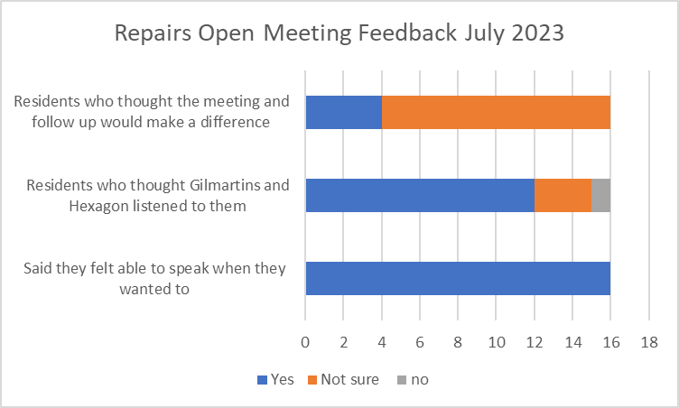
4.8 | The Resident Advisory Group is a Residents Group which reviews policies, makes recommendations and wording changes. The group has struggled with membership over the last couple of years for various reasons.  In 2023/24, 4 meetings were organised, however one 1 meeting was quorate.  The group considered two strategies. An early draft of the Resident Engagement Strategy was considered and 10 comments/suggestions made, all of which have been taken on board in the new strategy.  The Communications Framework was considered at a very early stage, several comments and suggestions made.  The Communications Framework was discussed with RAG members at near final stage (meeting inquorate). 11 suggestions were made, 9 of which were accepted and incorporated into the framework, 1 was noted, 1 update was given.  Outcome: 2 strategies were reviewed, 21 suggestions made, 19 of which were incorporated into the documents.
4.9 | Policy Consultation and Digital Pilot  Residents were consulted on a total of 3 polices and 2 strategies.  One of our priorities is to broader the number of residents engaged. We wanted to hear from more residents and piloted digital consultation with use of video.  We have introduced a dedicated Policy Consultation section of the website, where there is a clear audit trail from policy draft, comments, actions and final policy.  Outcomes of Pilot  - 19 survey responses received, plus Repairs Group – 24 residents in total providing 90 comments and suggestions on the policy  Although a low % response rate, the level of involvement is notably increased from previous policy consultations. The new process for policy consultation is in its formative stage and a body of invested interest will take some time to build-up. To date there are 33 residents who have registered interest in future policy consultations.  The chart below shows the different ways the policy information was accessed.  Video 38% (15)  Written summary 36% (14)  In-progress policy 26% (10)  Responses from 19 participants. Most referred to multiple information sources, 9 (47%) referred only to video and/or written summary indicating inclusion of these are significantly opening-up opportunities for engagement that meet different resident needs.
4.10 | 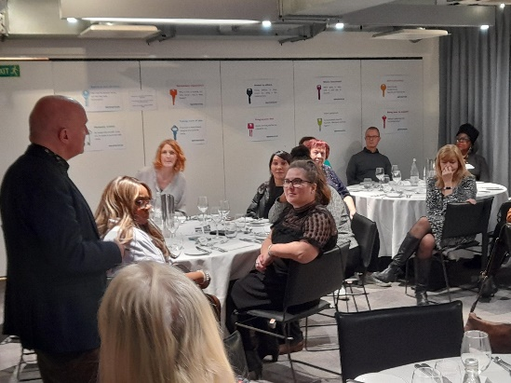  Recognition Evening  In March we held a Recognition Evening to say thankyou to our Resident Volunteers. The event focused on recognising and valuing the contribution residents make. The majority of our meetings are now held online, it was wonderful to experience the buzz of residents meeting face to face.  Photo: Barrie Hargove, Chair of Repairs Group speaking at the Recognition Evening
4.11 | Resident Engagement Strategy for High Rise Buildings  This was one of the priorities in the ADP. Work has commenced but is yet to be completed, and will carry forward as a priority for 2024/25.  There is an existing Resident Engagement Strategy for Property Safety, so we have an existing document to build upon. We have
4.12 | Develop a diversity and inclusion engagement plan for seldom heard groups.  This was one of the priorities in the ADP. Work has commenced on this, it features in the new strategy and is a priority for 2024/25. There is an existing Diversity and Inclusion Group, however the group has not met for some time and is struggling capacity wise. We will be working with DIG members, and seek to recruit others in the development of this plan.  We have worked collaboratively to develop ‘Hearing the Customer Voice’ and have produced a thought piece which will provide a reference point for moving this important work area forward. The Big Conversation is planned for Autumn 2024, we are also involved in the emerging work area on Vulnerable Residents, and seeking to collaborate with the Community Investment Team who have contact with upto 500 residents each year.
4.13 | Development of new Resident Engagement Strategy  This was another ADP priority. The strategy is written and ready for Board approval in May 2024.
5 | Communication
5.1 | Home News – Home news is produced quarterly. It is currently a print led design, with the digital version being a PDF which is emailed to residents.  The email distribution figures vary slightly each issue, the Spring 2024 edition was emailed to 3174 residents, of those email addresses 59 bounced and 7 unsubscribed from email copy.  1541 residents opened their digital version of Home News, this is a 48.55% open rate. Open rate varies between 46% and 55%.  We have found that the majority of residents who open the email are using a laptop. However, our most recent digital inclusion survey found that most of our online residents do so via mobile phone. PDF is not the most reader friendly format when being viewed on mobile phone, this may in part explain why a number of residents who have email addresses prefer to receive a hard copy of Home News.
5.2 | Residents Annual report – The report was co-designed with residents and colleagues. The report was integrated with Home News for cost efficiency.
6 | Resident Engagement Figures  The chart below shows the residents attending resident engagement activities in 2022/23 and 2023/24.  The figures above do not include residents engaging in surveys. We will work to roll these figures and other informal engagement activities into the figures moving forward. This is especially important in light of our shift to increased digital engagement in policies where 19 residents recently engaged in policy consultation and 33 registered their interest in future policy consultation.  The figures also exclude attendance at estate based meetings such as Parkspring and Atrium Court where meetings are regularly attended by 20 or so residents, and the recent Service Charge Information meetings which have been attended by a guesstimate of 150 residents.  Moving forward, we will refine the way we record the number of residents engaged and the type of activities.  Th chart above presents a year on year comparison.  In 2022/23, the Big Conversation engaged with 538 residents. Our intention is for this to be a bi annual activity, with the next one being held 2024/25.
7 | Value for Money
7.1 | Each engagement activity is costed in terms of inputs, outputs and outcomes. This includes staff and volunteer time, rewards and expenses, venue hire, refreshments.  This Annual Review has demonstrated a high level of resident engagement activities, though the impact of some of the activities has proved difficult to ascertain. It is important in all our activities that the intended impact and outcomes are clear from the outset, and colleagues are clear on the commitment required from them before any activities are embarked on. Without this in place, the value for money is reduced.  Moving forward, we must be realistic with our plans, adopting project management approach to resident engagement activities to ensure resources, capacity and commitment are in place and the intended outcomes clear.  The team spend a considerable amount of time on administrative duties, writing up minutes, sending emails, chasing up actions from colleagues. This is a considerable drain on resources and impacts on the teams ability to deliver. We are working to develop what we have called ‘the place’ where the trackers and actions can all be contained within one ‘place’ with timescales/service level agreements.  We will review Home News publication, and explore the switch to digital first design, especially for residents we know have email addresses and able to access copy online.
8 | Diversity  No diversity data is included in this report. It may be that data is located in a place I have yet to locate. A manual exercise could be undertaken matching residents against CX data, though with the unreliability of CX data, this is likely to be timely and ineffective. Once Resident Involvement moves to CX, the capturing of such data will be greatly enhanced.

