

Project Manager
Fixed Term Contract 12 Months

Recruitment Pack

October 2025





Contents

 | Page
Welcome letter | 3
About Hexagon | 4
About the Development Department | 6
Job description | 7
Person specification  Our Cultural Matrix & Care Behaviours | 9  10
Organisation chart | 12
Principal terms and conditions of service | 13
The advertisement | 14
Key dates and selection process | 15

Welcome letter

October 2025

Dear Candidate

Project Manager

Thank you for your interest in working for Hexagon Housing Association.

If you require a copy of this document in an alternative format please contact us on the details below.

As a provider of high quality housing and care services, we believe it is important to recruit talented individuals who share our vision to be the provider of choice.

We know that attracting and keeping the best people is the most effective way to build a successful business, so we are committed to investing in you and your future, offering a competitive remuneration package and providing extensive learning and development opportunities throughout your career.

This pack gives background information on Hexagon and the role you are applying for. Please make sure your application reaches us by CLOSING DATE – 12 noon, Wednesday 12th November 2025.

You will be contacted within ten working days of the closing date if you have been shortlisted. If we do not contact you, then please assume that you have been unsuccessful on this occasion.

Please note we do not accept CVs. Applicants must fully complete our online application form.

Good luck!

Hexagon Human Resources
Tel: 0208 768 7941
Email: recruitment@hexagon.org.uk
Web: www.hexagon.org.uk/careers

About Us

Hexagon Housing Association owns and manages approximately 4200 homes in south-east London and Kent. Most of our stock is general needs housing but our portfolio of shared ownership and leasehold housing is growing. We also have over 300 homes in Supported Housing schemes, about two thirds of which we manage ourselves and one third is managed by Supported Housing agencies. Co-operative managing agents manage about 300 of our general needs rented homes.

Our partner boroughs are Southwark, Lewisham, Greenwich, Bexley and Croydon, with a small number of homes in Bromley and Kent. We are building new homes for rent and shared ownership, currently mostly in Southwark, Croydon and Bexley. Our shared ownership and leasehold portfolio is expanding and is expected to continue to grow in the future.

Our homes include all types ranging from modern purpose built blocks of flats, through to Victorian houses converted into flats and houses. We do not manage any large estates – our biggest single estate is 100 flats – but we do manage a number of small estates and blocks.

As an organisation, we are concerned with people, their homes and communities. We make good quality, affordable housing and services available to people in South London, and work to extend opportunities and improve the neighbourhoods they live in.

Like all housing associations, Hexagon is a not-for-profit organisation and is regulated by the Regulator of Social Housing (RSH).

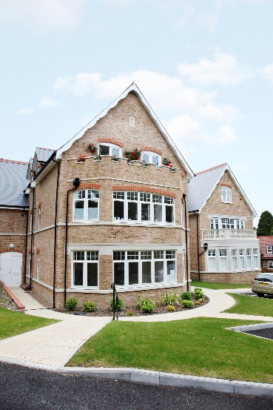
Hexagon currently employs 120 staff. We recognise the importance of making Hexagon a great place to work and are committed to continuously improving staff engagement. We are a certified Great Place to Work organisation with IIP Gold.

All of our staff are based at our office in Sydenham SE26 and although the office will be your place of work, our expectation is that office and home working is blended to ensure that it works for both staff and the organisation.

Our values are designed to enable us to:-

Put our Customers at the heart of what we do
Appreciate difference
Be Responsible (and accountable)
Empower our people

The Team

We are Greater London Authority (GLA) Investment Partners developing new homes in the London boroughs of Southwark, Lewisham, Greenwich, Bexley and Croydon.

We are completing delivery of circa 200 new homes over the next two years, largely funded by the GLA Affordable Homes Programme (2016-21)

Approximately 60% of the programme is shared ownership and the rest is for London affordable rent and social rent We have a small number of outright sale homes too.

Five of the six projects on site are land led, and some schemes have suffered setbacks due to contractor insolvency, which has led to delays and cost increases, so it is a complex, risky but very interesting programme to deliver.

Whilst there are no pipeline projects in the programme, the focus for future development will be on section 106 schemes We are keen to engage early with developer partners so we can influence design where possible and we have been making preparations for this new approach.
The team is currently being led by an Interim ‘Senior Development Lead’ following recent staffing changes. .

The Development team currently comprises 1 Project Manager, and an interim Administrator to progress the projects to completion and end of defects liability period

The Development team works closely with the Sales team who are responsible for, selling new shared ownership and existing homes to residents, as well as overseeing staircasing transactions and lease extensions It comprises of a Senior Sales Executive, and a Sales Executive.

We use SDS Proval to carry out scheme appraisals and SDS Sequel to manage the cashflow of schemes in development and are looking to expand into the Property function

We are looking for an experienced, versatile, solution focussed Project Manager who has the confidence to tackle complex contracts, can drive delivery, along with the business acumen to identify suitable s106 opportunities.

2025

Job Description
Job title: Project Manager

Responsible to: Interim Senior Development Lead

Purpose:
To financially appraise and project manage new schemes, from inception to on site to the end of the defects’ rectification period. Assist with proposals and bids

Principle Accountabilities:

- Oversee the progress of schemes on site, making regular site visits, attending site meetings, snagging, handover and end of defects inspections.

2. Prepare and submit grant claims to the GLA using the OPS system, and other funding authorities as appropriate

3. Monitor scheme expenditure and progress, maintain accurate financial records and report on expenditure, budgets, financial forecasts and key events to the Interim Senior Development Lead and the Finance Department

4. Assist the Interim Senior Development Lead to prepare the required information on new schemes to present at internal design panel meetings.

- Review project, consultant and contractor performance to ensure timely project delivery to agreed standards.

6. Liaise with internal and external client departments regarding client choices, ensuring compliance with the Employer’s Requirements.

7. Ensure schemes are constructed in accordance with the Employer’s Requirements and contract drawings.

8. Prepare financial feasibilities for new schemes, as required and manage and maintain financial feasibilities for existing schemes.

9. Ensure a project risk register is maintained on each project and escalate high risks to the Interim Senior Development Lead

10. Instruct architects to submit planning applications where required.

11 Instruct and liaise with consultants, where required to ensure project delivery.

12. Assist with bids/proposals for funding when necessary.

13. Assist with the resolution of latent defects.

14. Liaise with funders and local authority contacts as agreed by the Interim Senior Development Lead .

15. Manage good business relationships with external stakeholders and consultants

16. Prepare written reports as required on schemes in own workload for the Interim Senior Development Lead.

17. Prepare written reports as required for Risks Appraisal Panel (RAP) and the Directors Group.

18. Ensure that the relevant statutory consents are obtained for schemes, schemes comply with funding requirements and the association’s procedures and accurate documentation is held on file at all times.

19. Carry out all duties with regard to Hexagon’s Equality & Diversity and Health and Safety Policies.

20. Carry out any other reasonable related duties assigned by the Interim Senior Development Lead

General

- Act always in accordance with Hexagon’s published policies and procedures.

- Maintain high standards of probity and confidentiality.

- Take responsibility for self-development, attending training, supervision, appraisals, team meetings and staff conferences as required.

- Carry out all other duties as may be reasonably be assigned

Notes
- All tasks within this job description may be carried out on behalf of Hexagon Housing Association Ltd, it subsidiaries and any associated organisations.
- Post holders will always be consulted before job descriptions are amended.
Person Specification – Project Manager

Skills Required | Level
Work Experience/ Skills/Knowledge/ Abilities | Essential  Experience of working in a relevant housing or construction related field  Experience of using financial appraisal / cashflow tools such as SDS Proval / SDS Sequel  Experience of appraising and securing developer led Section 106 schemes  Ability to grasp and use technical, legal and financial information quickly and use it in day-to-day work. Ability to analyse information  Ability to use mathematical concepts and excel spreadsheets  Ability to instruct professional consultants appropriately and competently
Ability to communicate clearly verbally and in writing with individual and professional clients, funders and any other outside body
Understanding of GLA, grant funding, and Registered Provider roles, status and policies and procedures
Ability to organise own workload, work on own initiative and work under pressure
Willingness to work constructively and positively within a team
Full driving licence and access to a car
Awareness of building and design issues. Ability to read plans and an understanding of the client’s role in the development process
Desirable
Experience of GLA grant funded scheme work

Personal Qualities | Essential  Positive “can do” attitude with a commitment to providing a high standard of service to colleagues, external clients and residents  Demonstrable Commitment to and understanding of  Equal Opportunities and Diversity

You will only be short-listed from the details written on the application form if you meet all of the criteria ranked as Essential.

Our Culture Web and CARE Behaviours

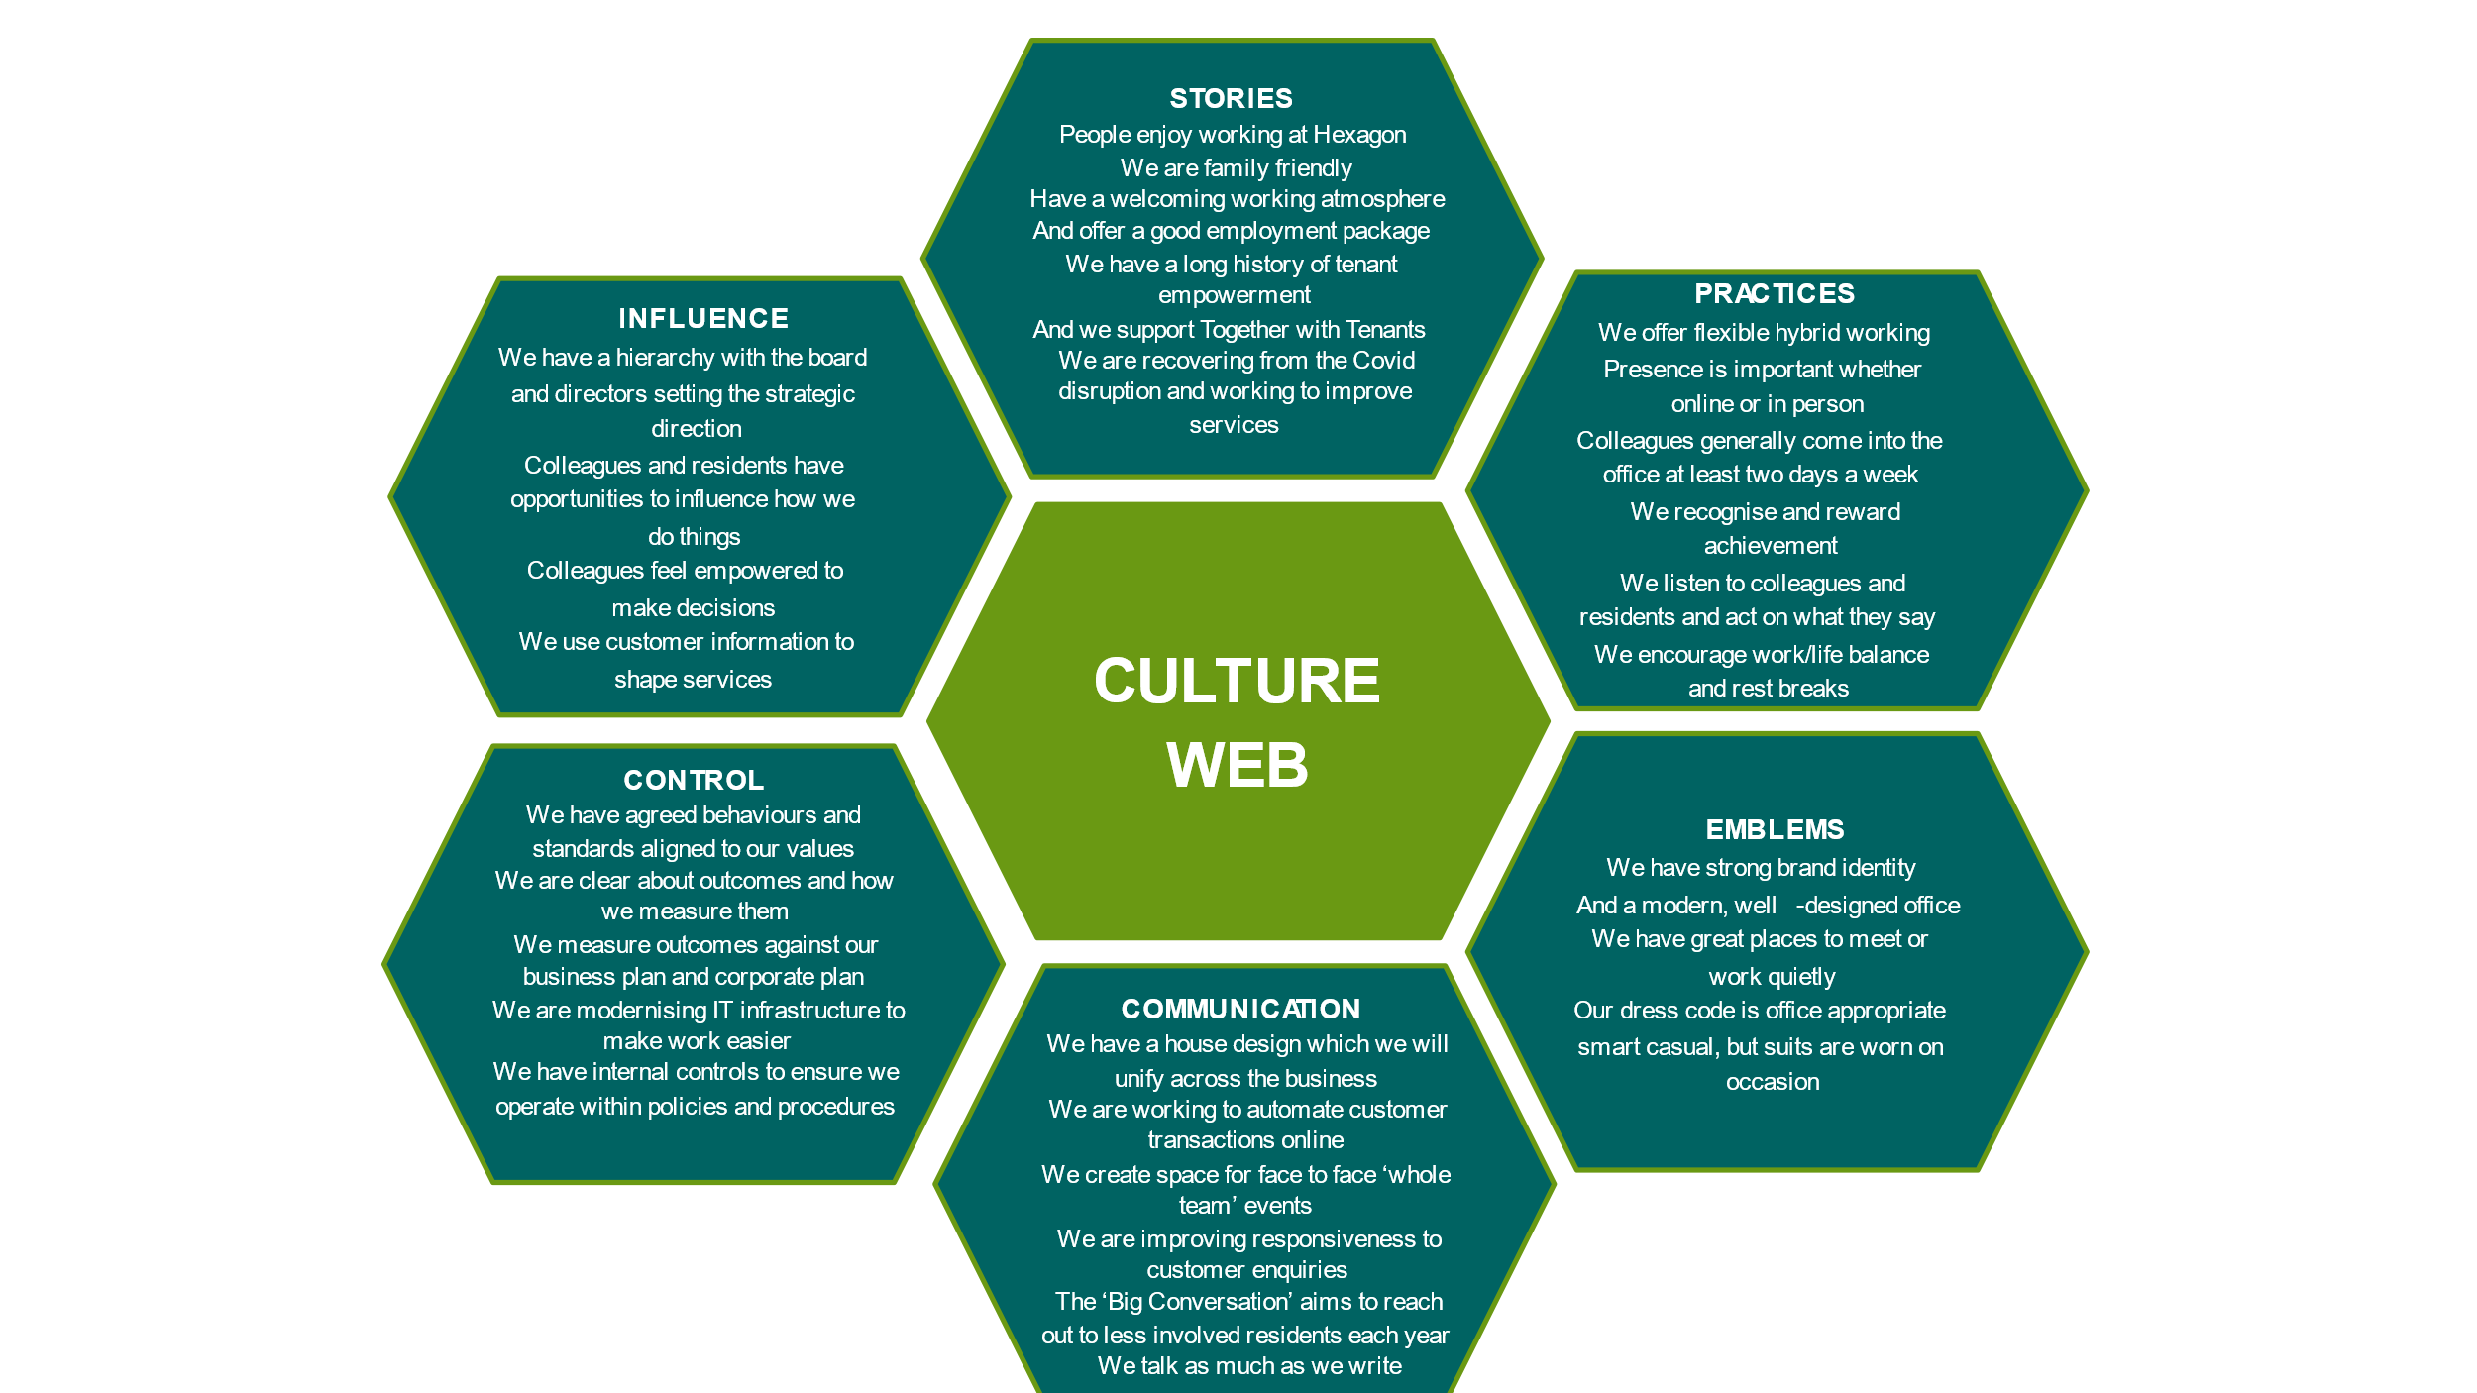

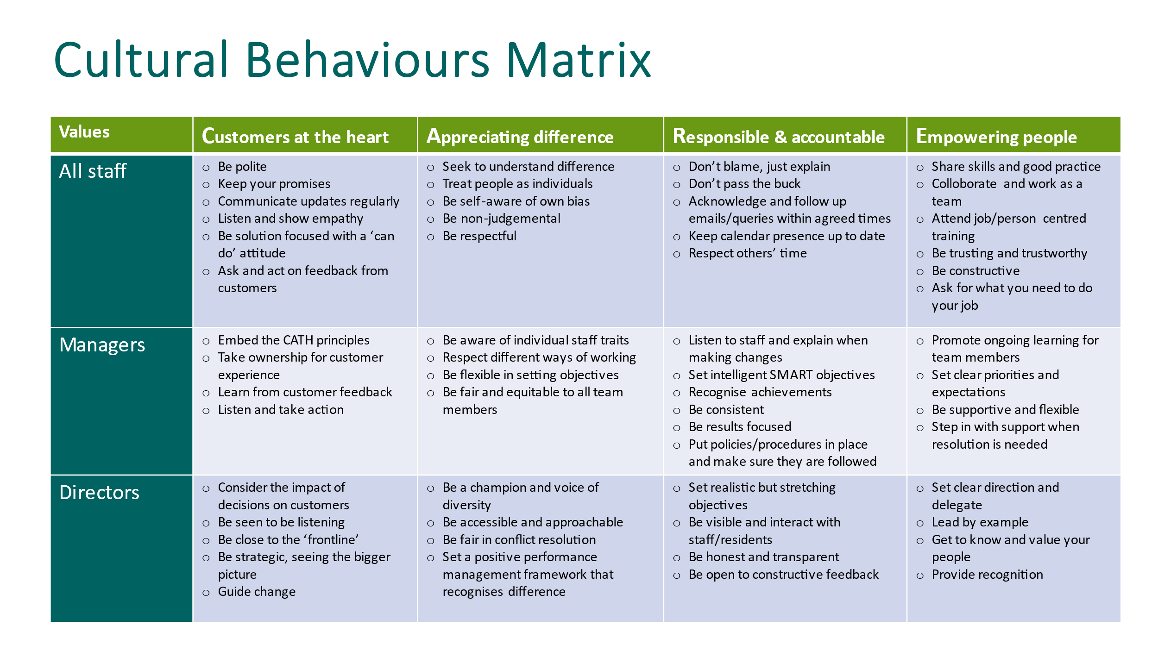

Organisation Chart –

?

?

Principal terms and conditions
(For information purposes only)

Working for Hexagon

We pride ourselves on providing a working environment which allows people to enjoy what they do, develop their skills and fulfil their potential. We are accredited by Investors in People with Gold status, demonstrating our commitment to the development of our staff. We offer excellent conditions of employment, and training programmes.

1. Position

Project Manager (Housing Development) - 12 month fixed-term contract

2. Remuneration

Salary £52,254 plus £7k Market Supplement and Essential Car User Allowance

3. Our generous range of benefits includes:

Core Benefits
- Defined Contribution Pension scheme.
- Career break scheme.
- Excellent Employee Assistance Programme (EAP)

Work life balance
- Hybrid Working/TOIL.
- Maternity, paternity & shared parental leave.
- Adoption Leave.
- Carers Leave.

Other Benefits
- Salary Sacrifice – Gym Membership Scheme.
- Salary Sacrifice – Car Leasing Scheme.
- Salary Sacrifice – Computer Scheme
- Season Ticket Loan
- Cycle 2 Work Scheme
- Private Medical Insurance

Rewarding our staff
- A comprehensive corporate training and development plan.
- Fully comprehensive induction and training for all employees.
- Staff Excellence Awards.
- Social Events.

4. Annual Leave

26 days plus 8 public holidays increasing by 1 day per annum up to 31 days.

5. Location

Your normal place of work will be our head office at 130-136 Sydenham Road
Sydenham, London SE26 5JY. Arrangements for Hybrid Working (office/home) will be discussed with the successful candidate.

6. Working hours

Full or Part-time - Full time – 35 hours per week

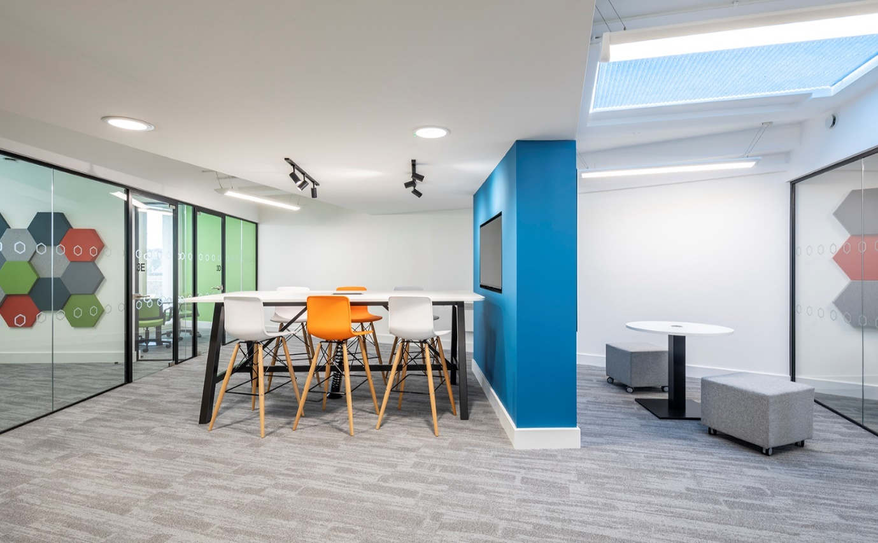

A workspace at our Sydenham Road Office

The Advertisement

Project Manager (Housing Development) – 12 month fixed-term contract
£52,254 plus £7k Market Supplement and Essential Car User Allowance
Full or Part-time
South East London (Hybrid Working)

Hexagon is an innovative and responsive housing association working in partnership with a range of local authorities to meet housing needs across Southeast London. With a turnover of £40m, 120 staff and over 4,000 homes, Hexagon is continually improving the quality and range of our affordable homes and services.

As an organisation we are concerned with people, their homes, and communities. We make good quality, affordable housing, and services available to people in the local areas we serve, and work to extend opportunities and improve the neighbourhoods they live in.

Are you interested in making a difference to the lives of people in South East London? We are completing delivery of circa 200 new homes over the next two years, largely funded by the GLA Affordable Homes Programme (2016-21)

Approximately 60% of the programme is shared ownership and the rest is for London affordable rent and social rent We have a small number of outright sale homes too.

Our Development team is responsible for delivering our on-site programme from start on site through to end of defects. You will manage the successful delivery of your schemes through effective management of your project teams and programme. You will be responsible for ensuring schemes are delivered on time, on budget, to a high standard and will provide excellent customer service.
We are looking for a highly motivated individual with relevant experience gained in residential development or a construction related field. You must have excellent communication, numeracy, organisational and IT skills (including experience of using financial appraisal/cashflow tools).
This role presents a brilliant opportunity to further your career with a dynamic Great Place to Work accredited company with IIP Gold, that is committed to employee engagement, values its staff and provides a work environment that is built on flexibility, empowerment, and a commitment to support you to be the best that you possibly can. If you want to work with a fantastic team and feel proud of the contribution that you make each day, then we very much want to hear from you.

We will offer you training and supervision to help you achieve your full potential, and an excellent package including private medical insurance, pension scheme with 3 x salary life assurance, flexible hybrid working (minimum expectation is 2 days per week office based), and 26 days annual leave rising one day per year to 31 days.

This role is available for 35 hours per week. Applications from those wishing to work part-time will also be considered.
For further details and how to apply, please visit our website at www.hexagon.org.uk. No agencies

Closing Date: 12 noon Wednesday 12th November 2025
Interviews will be held on Tuesday 25th November 2025

We are committed to building a diverse workforce and making Hexagon an inclusive place to work where everyone can be themselves and feel valued for their contribution.

Accessibility and Adjustments
We are committed to providing reasonable adjustments throughout the recruitment process to ensure inclusivity. If you have any specific requirements, please contact recruitment@hexagon.org.uk

Key dates and the selection process

Closing date: | Please make sure your application is submitted by - 12 noon Wednesday 12th November 2025
Short listing: | Tuesday 18th November 2025
Interviews: | Will be held face-to-face at our offices in Sydenham SE26 on Tuesday 25th November 2025  With Panel members ( Interim Development Lead and Senior HR Officer)

