

Rent & Service Charge Analyst

Recruitment Pack

November 2025






Contents

 | Page
Welcome letter | 3
About Hexagon | 4
About the Rent & Service Charge Team | 5
Job description  Person Specification | 6  9
Our Cultural Web and CARE Behaviours | 11
Organisation chart | 12
Principal terms and conditions of service | 13
The advertisement | 15
Key dates and selection process | 17

Welcome letter

Dear Candidate

Rent & Service Charge Analyst

Thank you for your interest in working for Hexagon Housing Association.

If you require a copy of this document in an alternative format, please contact us on the details below.

As a provider of high-quality housing services, we believe it is important to recruit talented individuals who share our vision to be the provider of choice.

We know that attracting and keeping the best people is the most effective way to build a successful business, so we are committed to investing in you and your future, offering a competitive remuneration package and providing extensive learning and development opportunities throughout your career.

This pack gives background information on Hexagon and the role you are applying for. Please make sure your completed application form reaches us by Sunday 30th November 2025.

You will be contacted within ten working days of the closing date if you have been shortlisted. If we do not contact you, then please assume that you have been unsuccessful on this occasion.

Good luck!

Hexagon Human Resources
Tel: 0208 768 7941
Email: recruitment@hexagon.org.uk
Web: www.hexagon.org.uk/careers

About Us
Hexagon Housing Association owns and manages approximately 4200 homes in south-east London and Kent. Most of our stock is general needs housing but our portfolio of shared ownership and leasehold housing is growing. We also have over 300 homes in Supported Housing schemes, about two thirds of which we manage ourselves and one third is managed by Supported Housing agencies. Co-operative managing agents manage about 300 of our general needs rented homes.

Our partner boroughs are Southwark, Lewisham, Greenwich, Bexley and Croydon, with a small number of homes in Bromley and Kent. We are building new homes for rent and shared ownership, currently mostly in Southwark, Croydon and Bexley. Our shared ownership and leasehold portfolio is expanding and is expected to continue to grow in the future.

Our homes include all types ranging from modern purpose-built blocks of flats, through to Victorian houses converted into flats and houses. We do not manage any large estates – our biggest single estate is 100 flats – but we do manage a number of small estates and blocks.

As an organisation, we are concerned with people, their homes, and communities. We make good quality, affordable housing, and services available to people in South London, and work to extend opportunities and improve the neighbourhoods they live in.

Like all housing associations, Hexagon is a not-for-profit organisation and is regulated by the Regulator of Social Housing (RSH).


Hexagon currently employs 113 staff. We recognise the importance of making Hexagon a great place to work and are committed to continuously improving staff engagement. We have held IIP Gold for several years. All of our staff are based at our office in Sydenham SE26 and although the office will be your place of work, our expectation is that office and home working is blended to ensure that it works for both staff and the organisation.
Our values are designed to enable us to:-

Put our Customers at the heart of what we do
Appreciate difference
Be Responsible (and accountable)
Empower our people
The Rent & Service Charge Team

Thank you for showing an interest in the Rent & Service Charge Analyst role.

The team is part of our Finance & IT Directorate and is led by the Rent & Service Charge Manager.

The rent and service charge team manages the setting and management of both rents and service charges. There is a separate accounting team leading on management and capital accounting and a transaction processing team dealing with supplier payments and invoicing.

Within our Neighbourhood Services Directorate there is a revenue team that focusses on the recovery of revenue across all tenures, and a Home Ownership Specialist who leads on leasehold tenancy management and Section 20 consultations.

Our current priorities

The strategic priorities for the Rent & Service Charge Team in the next year are:

- Maintaining Hexagon’s rental and service charge income.
- Ensuring compliance with regulatory standards and relevant legislation,
- Supporting the implementation of the new IT system and the re-engineering of existing procedures and working practices to improve the efficiency and effectiveness of rent and service charge work.
- Continued improvement in rent and service charge compliance, accuracy and quality.

Job Description – Rent & Service Charge Analyst
Job title: Rent & Service Charge Analyst

Responsible to: Rent & Service Charge Manager

Purpose:
- To set and regularly review rents and service charges, ensuring that customers and colleagues receive clear, accurate and timely information about the way we recover the cost of services at Hexagon’s properties.

- Be an in-house expert on rents and service charges, using training in regulations, best practice and residents’ housing needs. Ensuring Hexagon’s approach is compliant, transparent and fair.

- To provide expert support and advice to internal departments, to ensure that rent and service charge processes run smoothly and efficiently

Principle Accountabilities:

- Ensure rent and service charge setting is compliant with all relevant legislation, regulatory standards, contractual obligations, and internal policies.

- Play a key role in the annual rent review, from the regulated formulas for calculating rents to the issuing of statutory notices to all tenants.

- Maximise income through estimating all service charges as accurately as possible for all customer types, with reference to financial budgets, current legislation, Hexagon policy and occupation agreements.

- Reconcile actual costs against estimated service charge costs at the end of the financial year, producing audited accounts and informing the next budgets.

- Build service charges for new developments, liaise with internal/external clients to ensure management agreements are appropriate and property safety components are maintained.

- Resolve residents’ queries regarding accounts or costs recovery. Attending meetings and supporting tribunals if necessary.

- Collate and maintain details of freeholders/third party managing agents; and to process and confirm validity and accuracy of invoices received from management companies and utility companies through review, computation and dialogue, with a view to minimising cost.

- Calculate and monitor sinking funds, ensuring adequate funds are available for major works.

- Liaise with Property Services on planned and reactive works to ensure works are identified, costed and forecast; and Section 20 processes are properly followed, in accordance with the lease and legislation.

- Prepare for, evidence, and manage, the relevant audits.

- Support the Revenue Team to resolve disputes quickly on leasehold, shared ownership, general needs rent and service charges, r to ensure payment terms are met.

- Continuously review and refine rent-setting and service charge procedures to improve efficiency and effectiveness while maintaining full regulatory compliance.

- Provide a customer focused service ensuring customers receive quality information to explain their rent, service charge and sinking fund charges in line with regulation and legislation.

- Support the Rent and Service Charge Manager with formal complaint responses.

- Handle incoming enquiries by telephone, in person and in writing and to refer on where appropriate, delivering a positive outcome for both parties.

- Undertake tasks for other teams within the Finance & IT Directorate, in particular Management Accounts, as required.

- Provide training and support to colleagues in other departments to ensure effective collaborative working.

General:

- Act always in accordance with Hexagon’s published policies and procedures.

- Maintain high standards of probity and confidentiality.

- Take responsibility for self-development, attending training, supervision, appraisals, team meetings and staff conferences as required.

- Carry out all other duties as may be reasonably be assigned
Notes
- All tasks within this job description may be carried out on behalf of Hexagon Housing Association Ltd, its subsidiaries and any associated organisations.
- This Job Description does not form part of the post holder’s contract. This job description may be periodically reviewed to take account of changing demands. The post holder will be consulted before amendments to this job description are made.

Person Specification

Skills Required | Level
Work Experience | Essential  Highly numerate with meticulous attention to detail.  Knowledge and experience of rent and service charge processes for various tenures.  A natural problem-solver who seeks out challenges to be resolved and strives to improve the way problems are diagnosed and fixed in future.
Skills/Knowledge/  Abilities  Qualifications | Essential  Ability to analyse, understand and process sets of data, seeking out improvements and understanding outliers.  Ability to communicate confidently and clearly, orally and in writing with diverse groups.  Ability to solve multi-layered problems and develop consistent, streamlined solutions.  Ability to learn relevant legislation and best practice for service charge setting.  Experience with Microsoft office packages, including strong Microsoft Excel skills like vlookup, Pivot Tables, Power Queries etc., plus the confidence to develop your knowledge of software packages and tools.  Able to prioritise commitments and manage cyclical processes working in a way that best serves the team and other colleagues accurately and methodically, often under time-pressure.  Desirable  Ability to read and interpret leases and tenancy agreements  Experience of using and maintaining housing management, finance and CRM systems (preferably CX).  Evidence of identifying, initiating and implementing service improvements.  Knowledge of the affordable housing sector, regulatory and legal requirements and an expert understanding of rent & service charge legislation and practice  Essential  A professional housing qualification such as CIH or TPI, or willing to work towards this.  Desirable  Part qualified accountant (ACA, ACCA, CIMA or equivalent)
Personal Qualities | Essential  A positive “can do” attitude with a commitment to providing excellent customer service.  Able to work outside normal office hours on occasion.  Understanding of and commitment to equal opportunities.

Our Culture Web and Care Behaviours



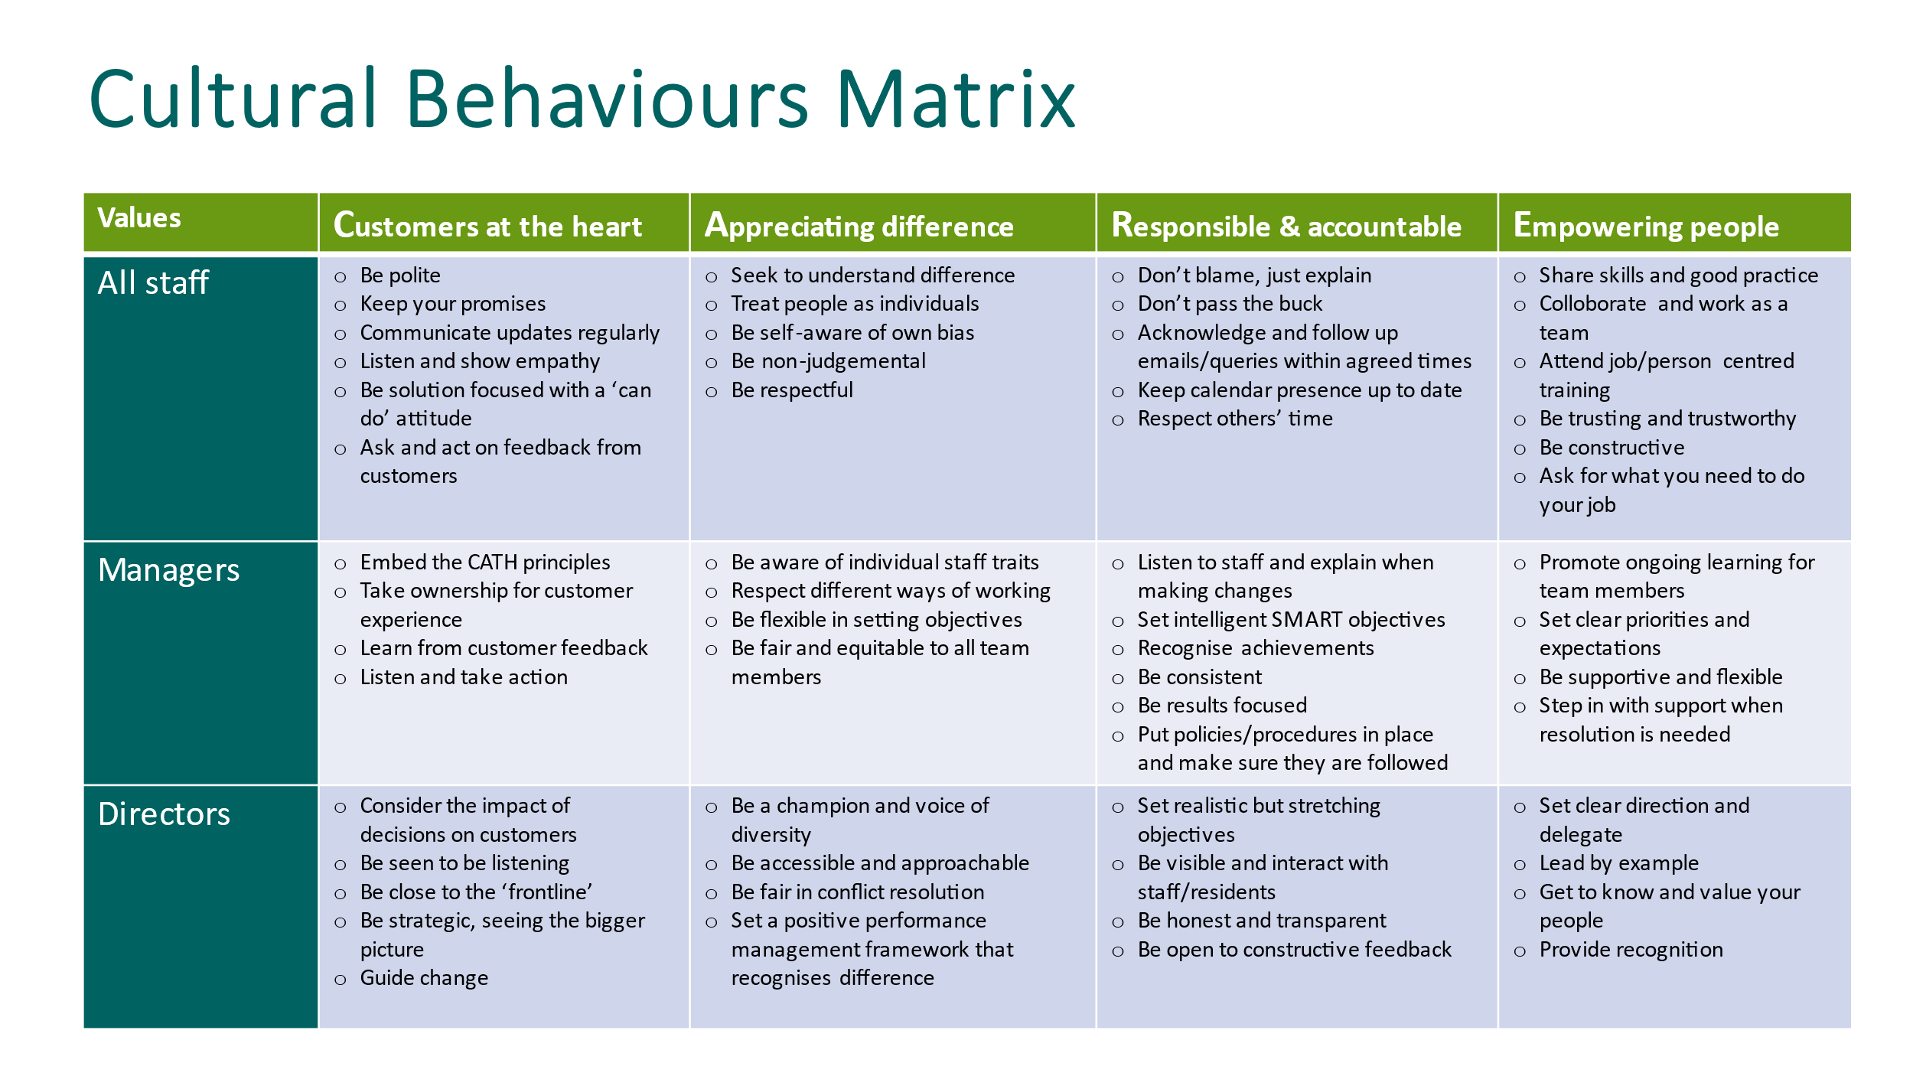

Organisation Chart – Finance Team

?

?

Principal terms and conditions
(For information purposes only)

Working for Hexagon

We pride ourselves on providing a working environment which allows people to enjoy what they do, develop their skills and fulfil their potential. We are accredited by Investors in People with Gold status, demonstrating our commitment to the development of our staff. We offer excellent conditions of employment, and training programmes.

1. Position

Rent & Service Charge Analyst

2. Remuneration

Salary £36,395 - £40,438 (dependent on experience)

3. Our generous range of benefits includes:

Core Benefits
- Defined Contribution Pension scheme.
- Career break scheme.
- Excellent Employee Assistance Programme (EAP)

Work life balance
- Hybrid Working/TOIL.
- Maternity, paternity & shared parental leave.
- Adoption Leave.
- Carers Leave.

Other Benefits
- Salary Sacrifice – Gym Membership Scheme.
- Salary Sacrifice – Car Leasing Scheme.
- Salary Sacrifice – Computer Scheme
- Season Ticket Loan
- Cycle 2 Work Scheme

Rewarding our staff
- A comprehensive corporate training and development plan.
- Fully comprehensive induction and training for all employees.
- Staff Excellence Awards.
- Social Events.

4. Annual Leave

26 days plus 8 public holidays increasing by 1 day per annum up to 31 days.

5. Location

Your normal place of work will be our head office at 130-136 Sydenham Road
Sydenham, London SE26 5JY. Arrangements for Hybrid Working (office/home) will be discussed with the successful candidate.

6. Working hours

Full time – 35 hours per week



The Advertisement

Rent & Service Charge Analyst
Salary £36,395 - £40,438 (dependent on experience)
Based London SE26, 35 hours per week (Hybrid Working – 2 days per week office based)
Hexagon is an innovative and responsive housing association working in partnership with a range of local authorities to meet housing needs across Southeast London. With a turnover of £40m, 120 staff and over 4,000 homes, Hexagon is continually improving the quality and range of our affordable homes and services.
As an organisation we are concerned with people, their homes, and communities. We make good quality, affordable housing, and services available to people in the local areas we serve, and work to extend opportunities and improve the neighbourhoods they live in.
We have an excellent opportunity for an outstanding candidate to join our Team and assist with the management of rent and service charges across Hexagon.
You will support the development and implementation of effective service charge management systems in addition to providing support to your colleagues on rent and service charge issues.
In addition to knowledge and experience of rent and service charge processes for various tenures, our ideal candidate will have:
- Ability to analyse, understand and process sets of data, seeking out improvements
and understanding outliers.
- Excellent communication skills with the ability to explain complex issues to customers and colleagues
- Excellent IT (including advanced Excel) and Numeracy Skills
- Experience of using housing management and financial systems (SUN and CX CRM desirable)
- Part qualified Accountant/relevant professional qualification (CIH/TPI) or willing to work towards this
- Ability to work outside office hours on occasion
This role presents a brilliant opportunity to further your career with a dynamic company that is committed to employee engagement, values its staff and provides a work environment that is built on flexibility, empowerment, and a commitment to support you to be the best that you possibly can. If you want to work with a fantastic team and feel proud of the contribution that you make each day, then we very much want to hear from you.
You will be joining a Great Place to Work accredited organisation with IIP Gold and we will offer you training and supervision to help you achieve your full potential, with an excellent
package including private medical insurance, pension scheme with 3 x salary life assurance, flexible hybrid working, and 26 days annual leave rising one day per year to 31 days.
If you think you have the skills to do all this and more, we want to hear from you. For further details about the role please visit our website www.hexagon.org.uk
Closing date: Sunday 30th November 2025
Interviews will be held in person on Thursday 11th December 2025
We are committed to building a diverse workforce and making Hexagon an inclusive place to work where everyone can be themselves and feel valued for their contribution.
Accessibility and Adjustments
We are committed to providing reasonable adjustments throughout the recruitment process to ensure inclusivity. If you have any specific requirements, please contact recruitment@hexagon.org.uk

Key dates and the selection process

Closing date: | Sunday 30th November 2025
Short listing: | Thursday 4th December 2025
Interviews: | Thursday 11th December 2025 - face-to-face at Hexagon’s Offices in Sydenham SE26 with the Rent & Service Charge Manager and Head of Finance.

