
Team Support Officer

Recruitment Pack

November 2025




Contents

 | Page
Welcome letter | 3
About Hexagon | 4
About the Neighbourhood Services Team | 6
Job description | 7
Person specification  Our Cultural Matrix & Care Behaviours | 9  10
Organisation chart | 12
Principal terms and conditions of service | 13
The advertisement | 14
Key dates and selection process | 15

Welcome letter

November 2025

Dear Candidate

Team Support Officer

Thank you for your interest in working for Hexagon Housing Association.

If you require a copy of this document in an alternative format please contact us on the details below.

As a provider of high quality housing and care services, we believe it is important to recruit talented individuals who share our vision to be the provider of choice.

We know that attracting and keeping the best people is the most effective way to build a successful business, so we are committed to investing in you and your future, offering a competitive remuneration package and providing extensive learning and development opportunities throughout your career.

This pack gives background information on Hexagon and the role you are applying for. Please make sure your application reaches us by Sunday 7 December 2025.

You will be contacted within ten working days of the closing date if you have been shortlisted. If we do not contact you, then please assume that you have been unsuccessful on this occasion.

Please note we do not accept CVs. Applicants must fully complete our online application form.

Good luck!

Hexagon Human Resources
Tel: 0208 768 7941
Email: recruitment@hexagon.org.uk
Web: www.hexagon.org.uk/careers

About Us

Hexagon Housing Association owns and manages approximately 4200 homes in south-east London and Kent. Most of our stock is general needs housing but our portfolio of shared ownership and leasehold housing is growing. We also have over 300 homes in Supported Housing schemes, about two thirds of which we manage ourselves and one third is managed by Supported Housing agencies. Co-operative managing agents manage about 300 of our general needs rented homes.

Our partner boroughs are Southwark, Lewisham, Greenwich, Bexley and Croydon, with a small number of homes in Bromley and Kent. We are building new homes for rent and shared ownership, currently mostly in Southwark, Croydon and Bexley. Our shared ownership and leasehold portfolio is expanding and is expected to continue to grow in the future.

Our homes include all types ranging from modern purpose built blocks of flats, through to Victorian houses converted into flats and houses. We do not manage any large estates – our biggest single estate is 100 flats – but we do manage a number of small estates and blocks.

As an organisation, we are concerned with people, their homes and communities. We make good quality, affordable housing and services available to people in South London, and work to extend opportunities and improve the neighbourhoods they live in.

Like all housing associations, Hexagon is a not-for-profit organisation and is regulated by the Regulator of Social Housing (RSH).

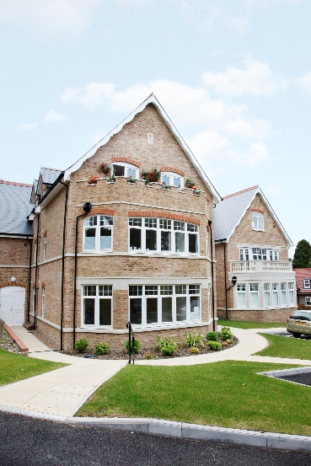
Hexagon currently employs 120 staff. We recognise the importance of making Hexagon a great place to work and are committed to continuously improving staff engagement. We are a certified Great Place to Work organisation with IIP Gold. All of our staff are based at our office in Sydenham SE26 and although the office will be your place of work, our expectation is that office and home working is blended to ensure that it works for both staff and the organisation.
Our values are designed to enable us to:-
Put our Customers at the heart of what we do
Appreciate difference
Be Responsible (and accountable)
Empower our people
The Team

Team Support Officer (Neighbourhood Services)
Information for Applicants

Thank you for showing an interest in the Team Support Officer role. Below is some background information about Hexagon, Neighbourhood Services, and this new role, which we hope you will find helpful.

Our Homes
Hexagon Housing Association owns and manages approximately 4200 homes in south-east London and Kent. Most of our homes are general needs housing, complemented by a growing shared ownership and leasehold portfolio of over 300 homes. We also provide around 250 supported housing homes, two thirds of which we manage ourselves. Co-operative managing agents manage around 300 of our general needs rented homes.
We work closely with our partner boroughs; Southwark, Lewisham, Greenwich, Bexley and Croydon, with a small number of homes in Bromley and Kent. Our development programme continues to expand, with new rented and shared ownership homes being built in Southwark and Lewisham.

Our homes range from Victorian conversions through to newly built blocks and small estates. While we do not manage large estates, we are responsible for a wide range of smaller blocks and neighbourhoods, each with its on character and challenges.
Our Office
The Neighbourhood Services team is based at our head office in Sydenham, London SE26 alongside colleagues from across the organisation. We operate a blended approach to office and home working, designed to balance service needs with colleague wellbeing.

Our office will be your place of work, although our expectation is that office attendance and home working are blended to work for our colleagues and the organisation. Our expectation is that colleagues work from the office at least 2 days a week.

The Housing Services Department

Our Neighbourhood Services Team led by the Operations Director and includes the Neighbourhood Services & Estates Manager, Neighbourhood Officers, Team Leaders, the Estate Services function, and the wider Resident Voice and Engagement Team.

Our focus for the coming years is to deliver safe, high-quality neighbourhood services, improve satisfaction, strengthen compliance, and support the implementation of service improvements.

About the Team Support Officer Role

This is a newly created role designed to strengthen capacity across the Neighbourhood Services Team. The postholder will work closely with the three Neighbourhood Team Leaders and the Neighbourhood & Estates Manager, providing essential support with:
- Project coordination
- Data and performance tracking
- Preparing reports, service updates and communications
- Organising meetings, follow-up actions, and maintaining key logs and workflows
- Supporting resident engagement and service improvement work
- Providing limited cover for core admin tasks during absence or peak demand

Our Involved Customers
Hexagon is known for strong resident involvement. Our Resident Voice & Engagement Team works closely with a passionate and skilled group of involved residents, from Board members to focus group participants.

The Team Support Officer will play a part in supporting communications, engagement activities and organising key meetings and interactions with residents.

Current Priorities for Neighbourhood Services
Our strategic priorities for the year ahead include:
- Maintaining rental income and supporting residents with the impacts of welfare reform
- Ensuring compliance with safety and regulatory requirements
- Strengthening policies and procedures to help us work more efficiently
- Improving results across all Tenant Satisfaction Measures

Hexagon as an Employer

We are committed to making Hexagon a great place to work and to supporting the development and wellbeing of all colleagues. We retained IIP Gold accreditation in 2021, reflecting our focus on leadership, involvement and continuous improvement. We are also a certified Great Place to Work.

Job Description
Job title: Team Support Officer (Neighbourhood Services)

Responsible to: Neighbourhoods & Estates Manager

Purpose:

To provide proactive administrative, coordination, and project support to the Neighbourhood & Estates Manager and Team Leaders. The role ensures effective delivery of housing services by supporting leadership, monitoring key initiatives, and assisting with higher-value housing processes.

Principle Accountabilities:

Leadership & Project Support
- Provide dedicated support to Team Leaders, including managing trackers, reports, and project timelines.
- Coordinate meetings, prepare agendas/minutes, and follow up on agreed actions.
- Support service improvement projects and initiatives, including assisting with policy/procedures reviews, collating feedback, and drafting updates.
- Liaise with internal teams to unblock issues for Team Leaders and facilitate efficient workflow.
- Provide reports and summaries to support decision-making by Team Leaders and the Manager

Resident & Stakeholder Support
- Draft communications for residents and support engagement events and consultation activities.
- Support the coordination of resident meetings and initiatives.

Continuous Improvement & Other Duties
- Maintain accurate records to ensure compliance with policies, procedures, and data protection.
- Contribute to service reviews, audits and improvement plans.

General
- Act always in accordance with Hexagon’s published policies and procedures.
- Maintain high standards of probity and confidentiality.
- Take responsibility for self-development, attending training, supervision, appraisals, team meetings and staff conferences as required.
- Carry out all other duties as may be reasonably assigned
Notes
- All tasks within this job description may be carried out on behalf of Hexagon Housing Association, its subsidiaries, and any associated organisations.

- This Job Description does not form part of the post holder’s contract. This job description may be periodically reviewed to take account of changing demands. The post holder will be consulted before amendments to this job description are made.

Person Specification – Team Support Officer

Level
Knowledge & Experience
Essential
Experience providing administrative or project support to managers or teams.

Strong organisational skills, with the ability to prioritise multiple tasks.

Proficient in IT systems (MS Office, databases, spreadsheets).

Excellent communication skills, both written and verbal.

Accuracy and attention to detail.

Ability to work independently and proactively

Desirable

Experience in housing, neighbourhood management, or local authority/registered provider environment.

Understanding of social housing services and resident needs.

Experience supporting projects or service improvement initiatives.

Knowledge of safeguarding and data protection principles.
Personal Qualities
Essential
Committed to excellent customer service.

Professional, approachable, and able to build strong relationships with colleagues and residents.

Flexible, adaptable, and positive in the face of change.

Resilient under pressure, solution-focused, and calm.

Team player who can also work independently.

Committed to equality, diversity, and inclusion.
Willingness to learn and develop within the role.

Advice to applicants

The above specification will be used in the shortlisting process.
As a minimum, candidates must cover the requirements marked as ‘Essential’ in their application where the Application Form has been identified as one of the methods of assessment.

Our Culture Web and CARE Behaviours



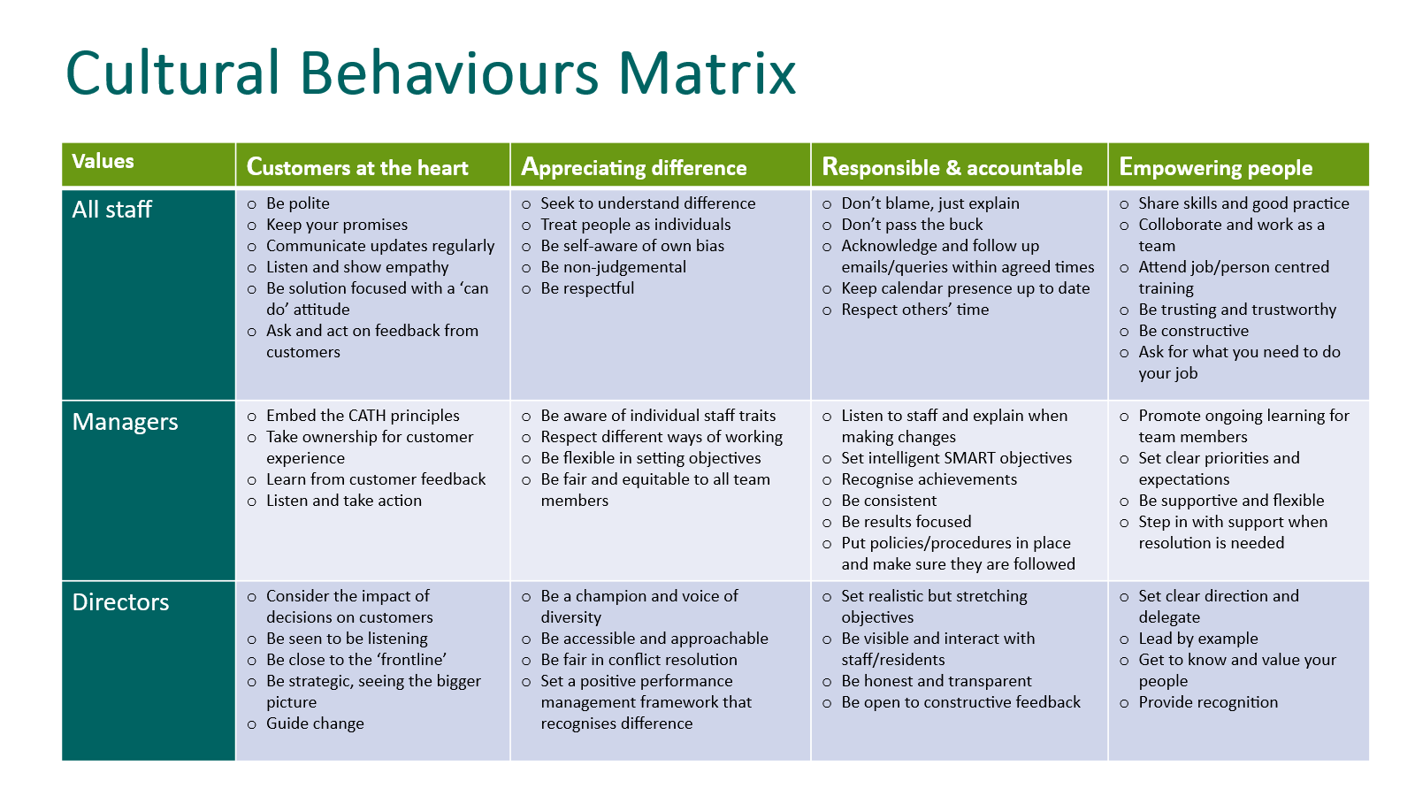

Organisation Chart –

?

?

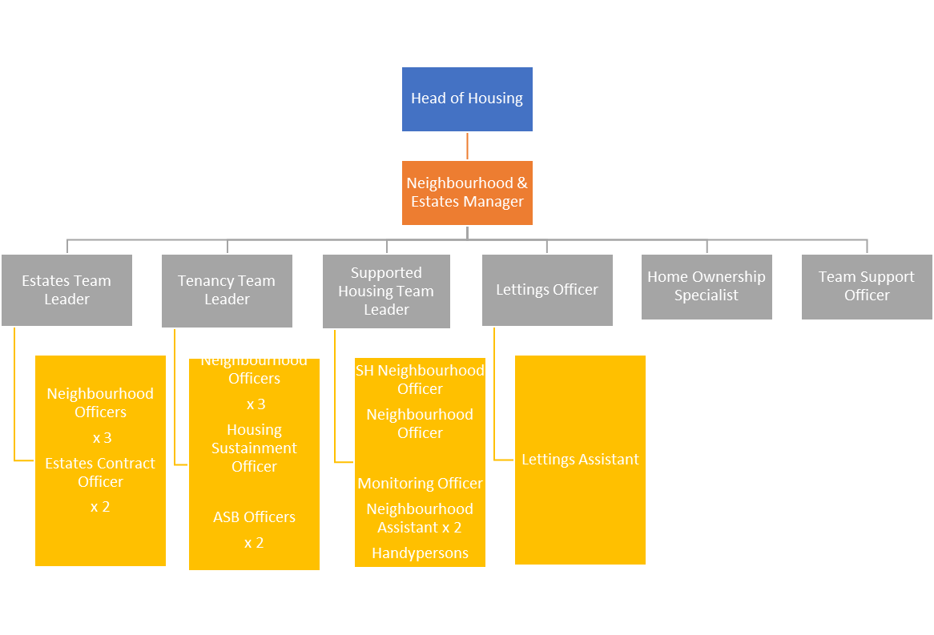

Principal terms and conditions
(For information purposes only)

Working for Hexagon

We pride ourselves on providing a working environment which allows people to enjoy what they do, develop their skills and fulfil their potential. We are accredited by Investors in People with Gold status, demonstrating our commitment to the development of our staff. We offer excellent conditions of employment, and training programmes.

1. Position

Team Support Officer

2. Remuneration

Salary £31,075 - £34,524 depending on experience

3. Our generous range of benefits includes:

Core Benefits
- Defined Contribution Pension scheme.
- Career break scheme.
- Excellent Employee Assistance Programme (EAP)

Work life balance
- Hybrid Working/TOIL.
- Maternity, paternity & shared parental leave.
- Adoption Leave.
- Carers Leave.

Other Benefits
- Salary Sacrifice – Gym Membership Scheme.
- Salary Sacrifice – Car Leasing Scheme.
- Salary Sacrifice – Computer Scheme
- Season Ticket Loan
- Cycle 2 Work Scheme
- Private Medical Insurance

Rewarding our staff
- A comprehensive corporate training and development plan.
- Fully comprehensive induction and training for all employees.
- Staff Excellence Awards.
- Social Events.

4. Annual Leave

26 days plus 8 public holidays increasing by 1 day per annum up to 31 days.

5. Location

Your normal place of work will be our head office at 130-136 Sydenham Road
Sydenham, London SE26 5JY. Arrangements for Hybrid Working (office/home) will be discussed with the successful candidate.

6. Working hours

Full time – 35 hours per week



A workspace at our Sydenham Road Office

The Advertisement

Team Support Officer (Neighbourhood Services)
SALARY £31,075 - £34,524 (dependent on experience)
Full-time – 35 hours per week
South East London - Hybrid

Hexagon is an innovative and responsive housing association working in partnership with a range of local authorities to meet housing needs across Southeast London. With a turnover of £40m, 120 staff and over 4,000 homes, Hexagon is continually improving the quality and range of our affordable homes and services.

Are you looking to utilise your excellent administrative and communication skills to help us deliver an excellent service to our residents? If so, this could be the role for you. We are looking for a Team Support Officer to join our dynamic Housing Team to provide proactive admin, co-ordination and project support to our Neighbourhood Services management team. Our ideal candidate will have:

- A proven background of providing administrative or project support to managers or teams.
- A commitment to excellent standards of customer care.
- Good IT skills (MS Office and databases).
- Excellent verbal and written communication skills.
- Excellent organisational skills.
- Accuracy and attention to detail.

Experience of working in housing, neighbourhood management, or local authority/registered provider and an understanding of social housing services and residents needs are desirable.

As an organisation we are concerned with people, their homes, and communities. We make good quality, affordable housing, and services available to people in the local areas we serve, and work to extend opportunities and improve the neighbourhoods they live in

We are a dynamic company that is committed to employee engagement, values its staff and provides a work environment that is built on flexibility, empowerment, and a commitment to support you to be the best that you possibly can. If you want to work with a fantastic team and feel proud of the contribution that you make each day, then we very much want to hear from you.

We will offer you training and supervision to help you achieve your full potential, and an excellent package including essential car user allowance, pension scheme with 3 x life assurance, flexible hybrid working (minimum 2 days per week office based), and 26 days annual leave

For further details and how to apply, please visit our website at www.hexagon.org.uk.
No agencies

Closing Date: Sunday 7th December 2025
Interviews will take place on Thursday 18th December 2025

We are committed to building a diverse workforce and making Hexagon an inclusive place to work where everyone can be themselves and feel valued for their contribution.

Accessibility and Adjustments
We are committed to providing reasonable adjustments throughout the recruitment process to ensure inclusivity. If you have any specific requirements, please contact recruitment@hexagon.org.uk

Key dates and the selection process

Closing date: | Please make sure your application is submitted by Sunday 7 December 2025
Short listing: | Wednesday 10th December 2025
Interviews: | Will be held face-to-face at our offices in Sydenham SE26 on Thursday 18 December 2025  With Panel members (Neighbourhood Estates Manager & Neighbourhood Team Leader)

